**DAILY ONLINE ACTIVITIES SUMMARY**

|  |  |  |  |  |  |  |  |  |
| --- | --- | --- | --- | --- | --- | --- | --- | --- |
| **Date:** | **12-07-2020** | | | | | **Name:** | **Sannidhi P** | |
| **Sem & Sec** | **8th sem B sec** | | | | | **USN:** | **4AL16CS084** | |
| **Online Test Summary** | | | | | | | | |
| **Subject** | | **-** | | | | | | |
| **Max. Marks** | | **-** | | **Score** | | | **-** | |
| **Certification Course Summary** | | | | | | | | |
| **Course** | **JAVASCRIPT Tutorial** | | | | | | | |
| **Certificate Provider** | | | **SOLOLEARN** | | **Duration** | | | **2hrs** |
| **Coding Challenges** | | | | | | | | |
| **Problem Statement-**write a c program to sort an array of integers in ascending or descending order and display the sorted array and number of passes performed for sorting  . | | | | | | | | |
| **Status: completed** | | | | | | | | |
| **Uploaded the report in Github** | | | | | **yes** | | | |
| **If yes Repository name** | | | | | **Sannidhi1** | | | |
| **Uploaded the report in slack** | | | | | **yes** | | | |

Online Test Details: (Attach the snapshot and briefly write the report for the same)

Test was good and was not able to see the platform properly as the platform was not that good

Certification Course Details: (Attach the snapshot and briefly write the report for the same)

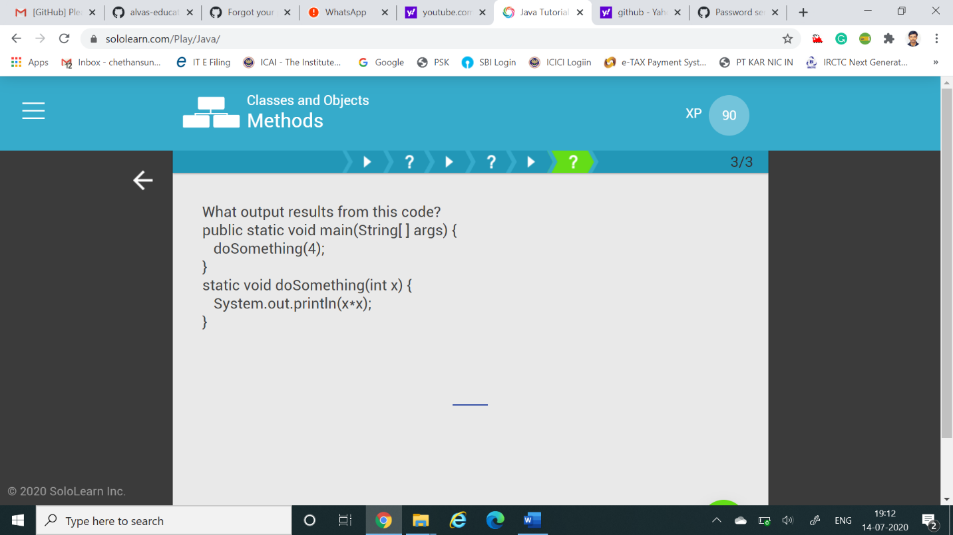

Coding Challenges Details: (Attach the snapshot and briefly write the report for the same)

Coding was given n it was uploaded for github and slack

PROGRAM1

#include stdio.h

void swap(int *xp, int *yp)

{

int temp = *xp;

*xp = *yp;

*yp = temp;

}

int bubbleSort(int arr[], int n)

{

int i, j,count=0;

int swapped;

for (i = 0; i < n-1; i++)

{

swapped = 0;

for (j = 0; j < n-i-1; j++)

{

if (arr[j] > arr[j+1])

{

swap(&arr[j], &arr[j+1]);

swapped = 1;

count++;

}

}

if (swapped == 0)

break;

}

return count;

}

void printArray(int arr[], int size)

{

int i;

for (i=0; i < size; i++)

printf("%d ", arr[i])

printf("\n");

}

int main()

{

int arr[50],num;

printf("enter the number of elements");

scanf("%d",&num);

printf("enter the elements");

for(int i=0;i=n;i++)

}